Confidence Exam
Setting and achieving goals builds self-
actualization. This helps develop good self-
confidence. Prepare for this self-confidence exam
by taking a close look at yourself. Read each
statement then circle the number that indicates
where you think you best fit. Total the circled
numbers and check your results in the key below.

NEVER OCCASIONALLY USUALLY
1. Basically, I am satisfied with myself. 1 2 3 4 5

2. I am happy with the way I look. 1 2 3 4 5

3. I am pleased with my relationships. 1 2 3 4 5

4. I can accept criticism without getting upset. 1 2 3 4 5

5. I keep trying when things don’t go my way. 1 2 3 4 5

6. I am glad for others when good things happen. 1 2 3 4 5

7. I am willing to seek help if I need it. 1 2 3 4 5

8. I enjoy the challenge of trying new things. 1 2 3 4 5

9. I feel comfortable meeting new people. 1 2 3 4 5

10. I set goals and expectations for myself. 1 2 3 4 5

Total score __________
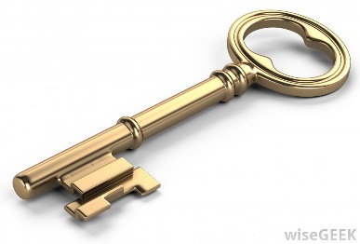
Key
Total Score
41- 50 Your self-confidence is GREAT!
31- 40 You are mostly satisfied with yourself.
21- 30 Your self-confidence is lacking.
10- 20 You need to work on your self-confidence.

Do you have the confidence that you desire? If so, good for you! If not, make some changes and keep trying!

