It’s All in Your Head
What does your brain contain? The picture of the brain is divided into sections. In
each section write or draw what you spend the most time thinking about.

Optimism is the
ability to look at
the brighter side of
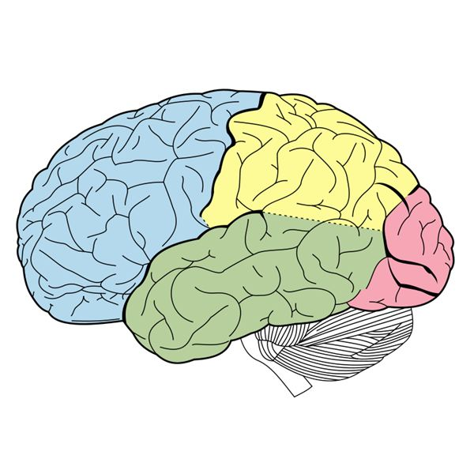
life and to maintain a
positive attitude, even in
the face of adversity.
Next, using a
different color
pen or pencil,
write positive
thoughts to
fill your brain.

