Take A Look At This
Take a look at the warning signs of stress listed below. Check EACH of
the warning signs that apply to you. When you are finished checking
your warning signs, discuss your list with someone you c an trust. Are
there any similarities? How much stress do you think you are currently
under? Discuss ways that you can eliminate some of the stress that could
start to cause you physical or emotional or behavioral difficulties.

Physical Emotional Behavioral
____ headaches ____ mood changes ____ smoking
____ stomach aches ____ lack of concentration ____ nail biting
____ dizziness ____ nightmares ____ tapping
____ back pain ____ panic attacks ____ pulling hair
____ neck stiffness ____ anxiety ____ grinding teeth
____ ulcer sores on mouth ____ anger ____ alcohol use
____ jaw pains ____ irritability ____ medication use
____ weight loss ____ crying ____ compulsive dieting
____ weight gain ____ thoughts of suicide ____ hair chewing
____ twitches (eyelids, face) ____ depression ____ nervous laughter
____ weakness ____ confusion ____ pacing
____ nausea ____ feelings of helplessness ____ lateness
____ indigestion ____ restlessness ____ putting things off
____ excessive sleeping ____ racing thoughts ____ not caring about
____ overeating ____ aggressiveness physical appearance
____ loss of appetite ____ compulsive
____ inability to sleep overeating
____ skin problems
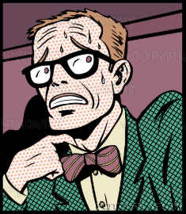
____ constant fatigue
____ cold hands or feet
____ excessive sweating
____ chest pains
____ high blood pressure
____ rapid or difficult breathing

