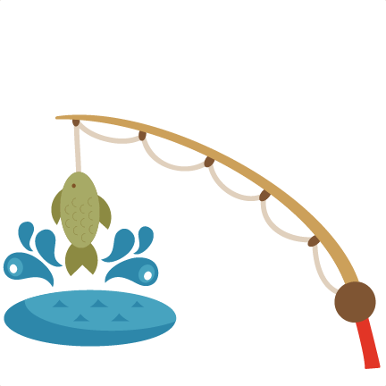
Name ____________________________

Fishing for Compliments
We all need compliments once in a while. Write your name in the space provided,
and then pass this paper around to someone in your group. When you receive a paper, in
the spaces provided, write a compliment to the person whose name is at the top. Continue
to pass the paper around until it is filled with compliments then return it to the owner.
How does it feel to receive so many compliments?

