Page 6
Learn to deal with your feelings in a positive way.
Today I Feel…
Use the picture below to identify how you feel today. Once you determine your emotional
feelings, you can respond by making smart choices as you interact with others throughout
the day. Recognizing your feelings and making a conscious decision to react positively to
your feelings is the difference between a good day and a bad day. You have the capability
to make this the best day of your life.

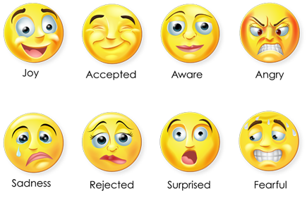

How do you feel today?

